**Task 3. Create IAM Group:**

1. **Create a new IAM group.**
2. **Attach the AmazonEC2FullAccess policy to the group.**
3. **Add User to Group**

**Steps for the IAM group creation.**

* In the IAM console, click on "User groups" on the left side menu.

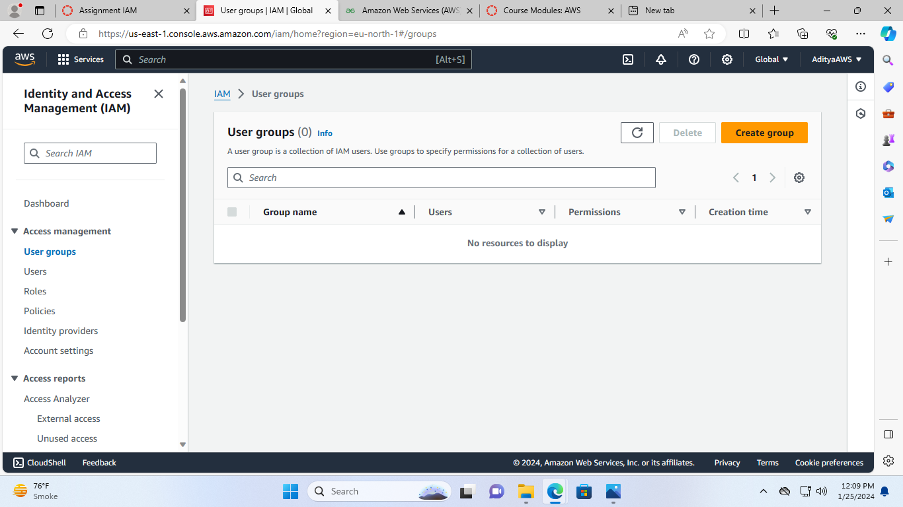

* Now, name the group.

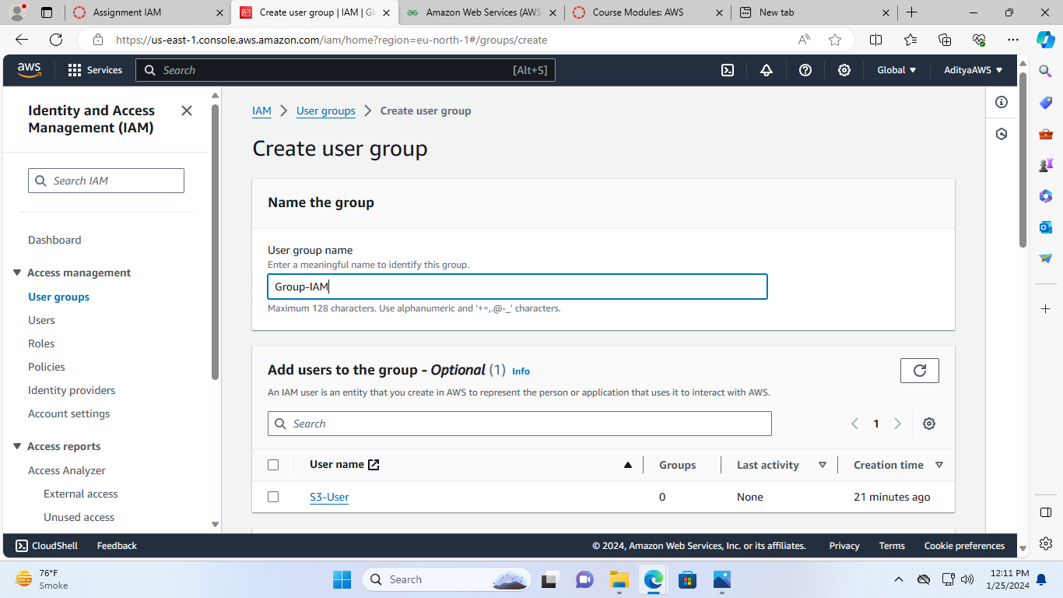

* Scroll down and in Attach permissions policies menu : Search **AmazonEC2FullAccess**and check the box.

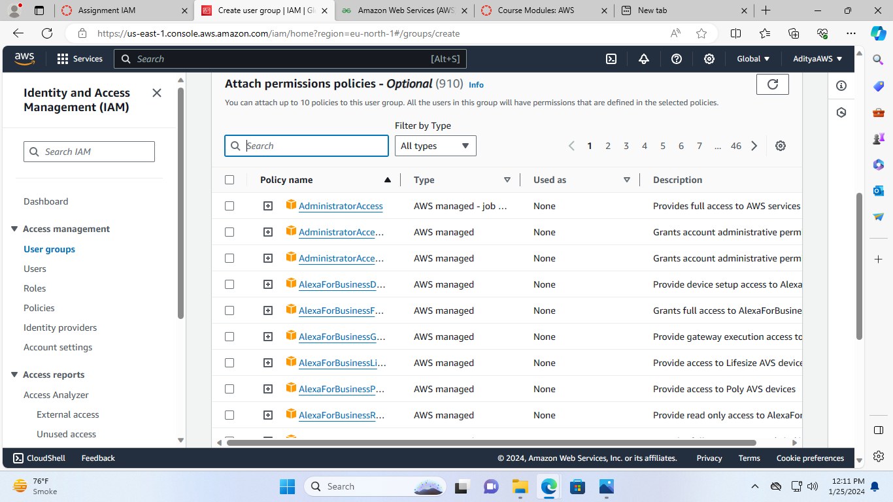

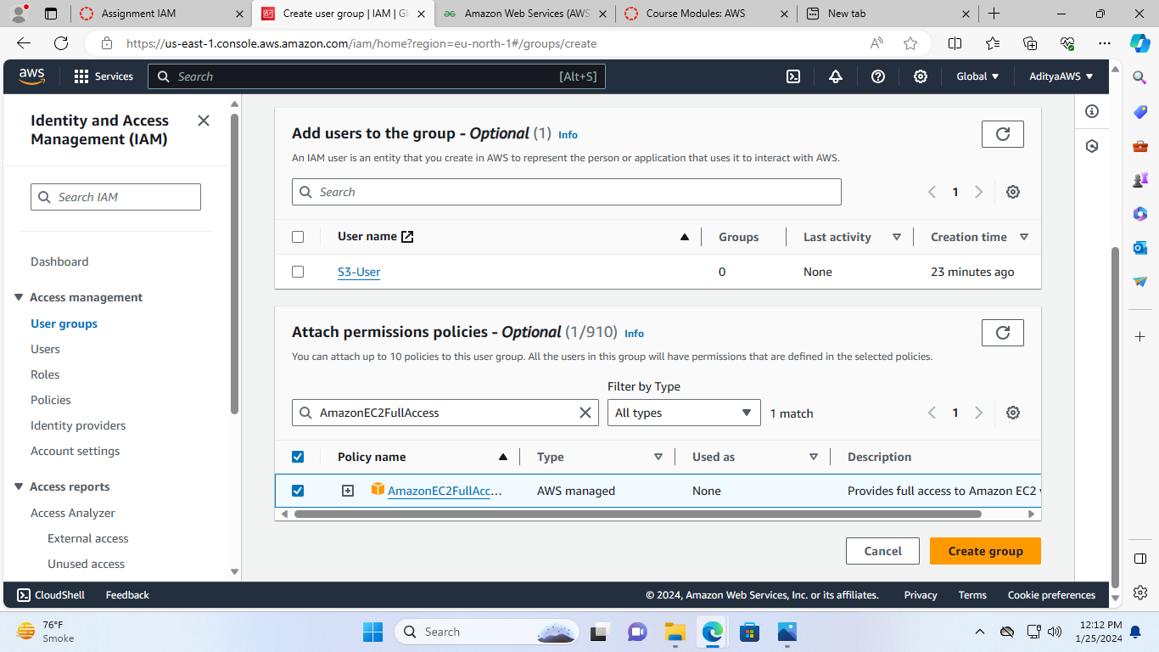

* And In Add users to the group menu check the box of S3-User

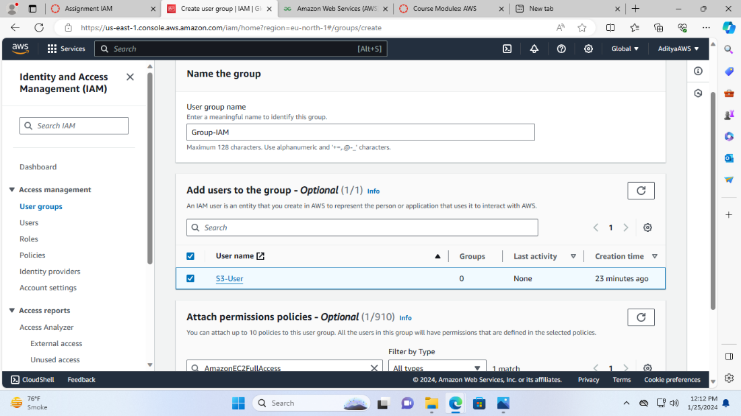

* Now, click “Create group”.

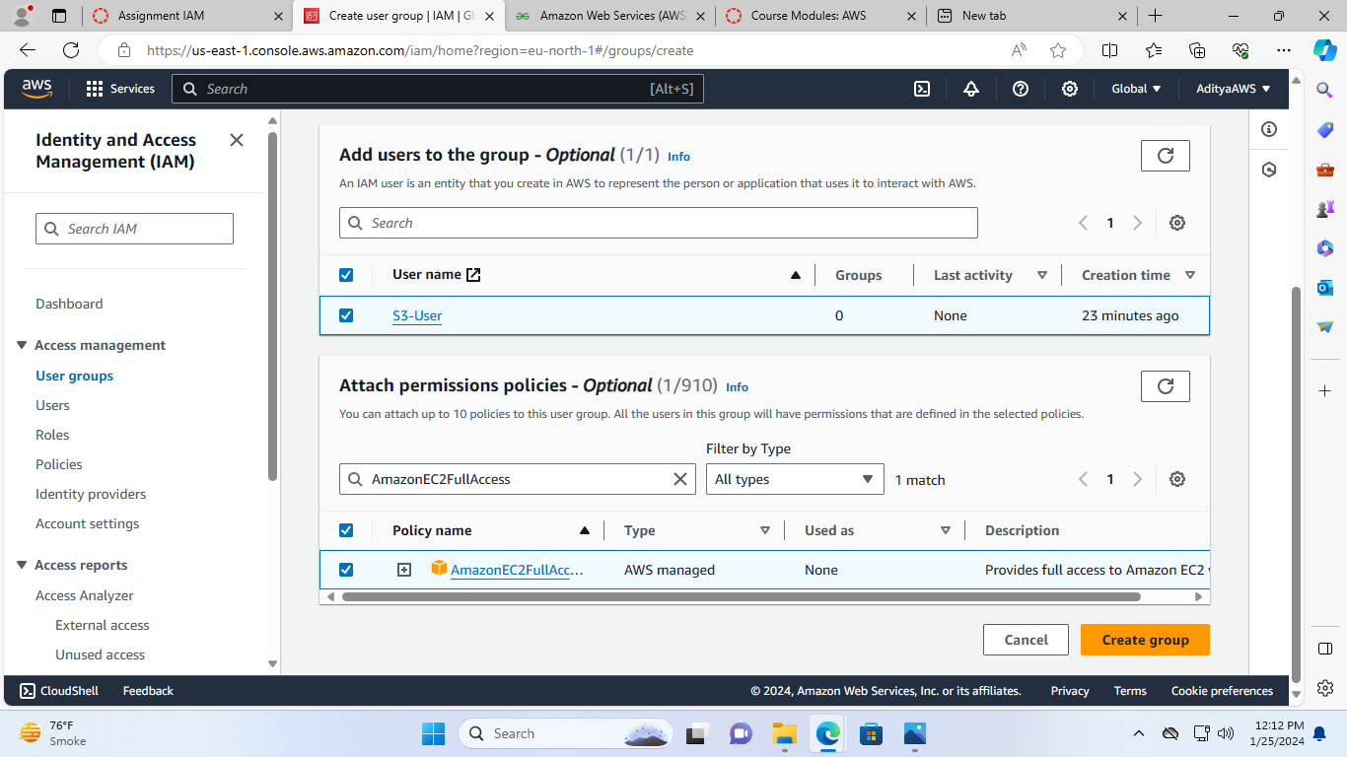

Now, the group is created successfully.

